Shopping With Coupons

Chapter 1: Introduction
In this project we aim to find the max number of items we can buy given limited dollars. There are total N items in our shopping list , also N kinds of coupon that can be used to save money. Each item can use as much as coupon as long as they are diffirent kinds. And each coupon is limitless which means if you buy item A using coupon x , even though you can’t buy A again using coupon x, you can buy B using coupon x. After all , you should find they maximal number of items using coupons if there is money left print it out also.

Chapter 2: Algorithm Specification
It’s clear that everytime we buy the items ,we should find the min cost using the coupon that we can use.So in our project we first sort the cost of each item and the value of the coupons . Firstly, we thought a way that simply substract cost and value then using a min heap to pop out which item to buy next time. However , after discussing we find a faster way to sovle the problem , that is each time there only some way to choose next item, let’s assume that the last item we buy is i , and the coupon it used is x, then the next one to buy is limited. Here is the gragh to show:
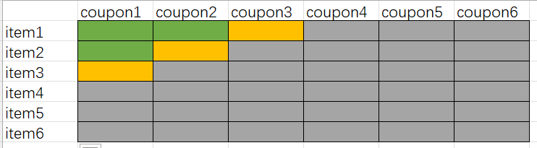
You can see that if green is choosen then the only possible way to choose next item is one of the yellow ones. According to this preperty , we don’t have to calculate all answer and push them into the heap , instead we can calculate what we may need and then push it into the min-heap.So each round we pop a item from the heap and check if its next item with first coupon is bought or not. If not we should add this item with first coupon into the heap . Then we push current item with next coupon into the heap.
In this way , only the possible item and coupon will be calculated. By checking current money during each round , we can quickly break from the loop and print out the answer.

Chapter 3: Testing Results
Sample input and it’s output:
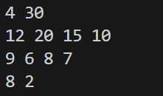
Then I will show some of test data we use, in this case we keep D to be the maximal value it can reach. Otherwise it the data we created may be unable to be used.
N = 10 while D = 1000000
Input:
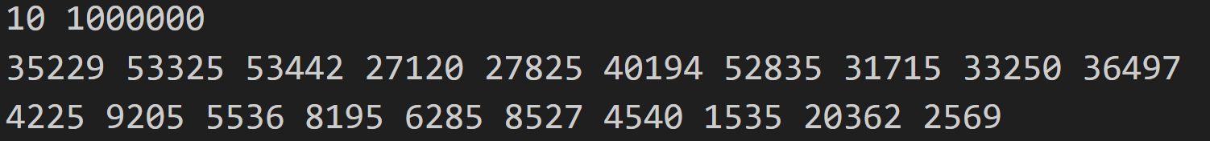
Output:
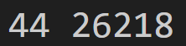

N = 1000 while D = 1000000
Input:
(the data is too large to show all)
Output:
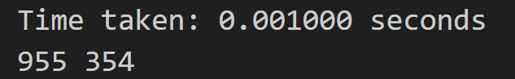

The two sample above was created ramdomly to check if program can run correctedly
Here is the maximal N:100000
Input:
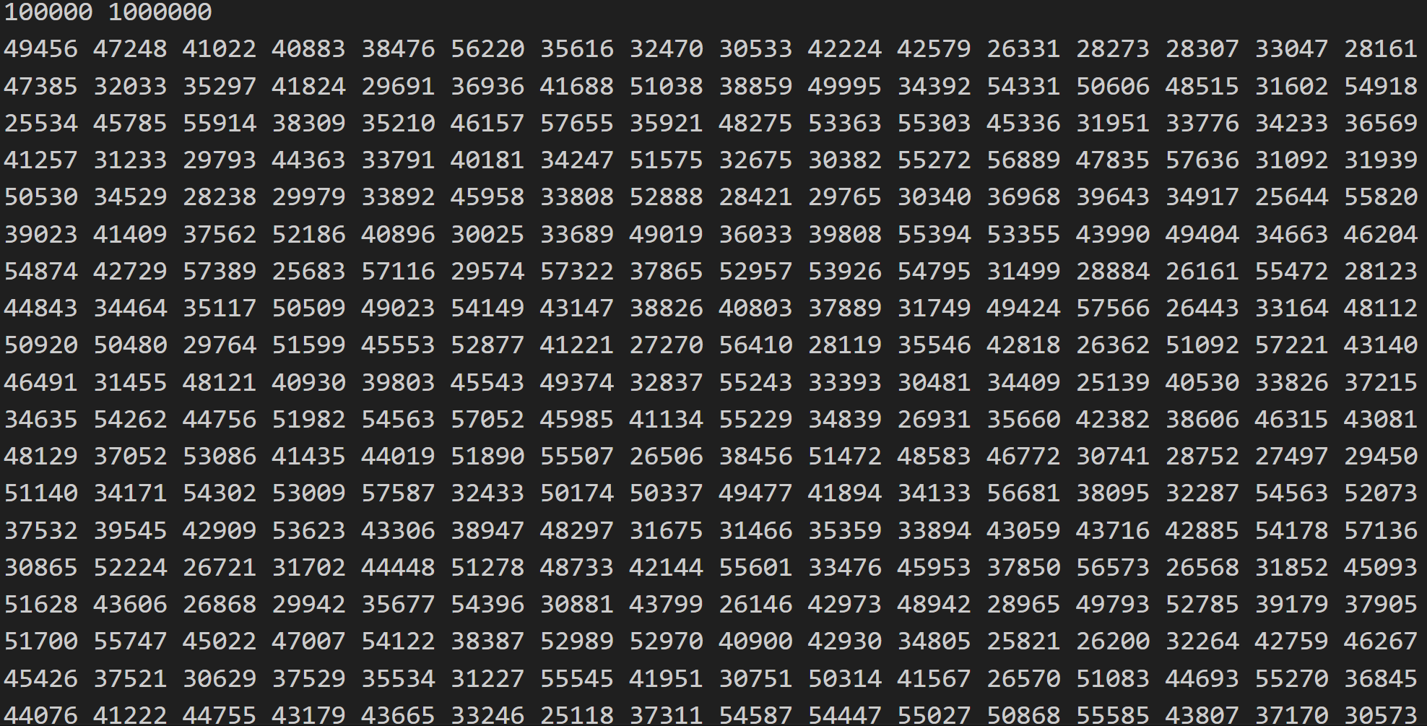
Output:
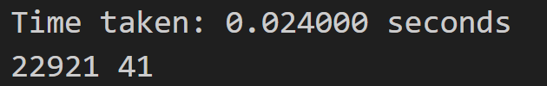
You can see that even in the largest N case ,the program can still run the result very quickly , because of the limitation of our D, a lot data is not used.

Chapter 4: Analysis and Comments
By using greedy algorithm , we find a way to sovle the problem easily. The greedy principle is that each time we only buy the cheapest item (after using the coupon).
The time complexity is O(n^2logn) . Though there are N items and N coupons , but the maximal nodes in the min-heap is n , so if using heap-merge it will cost O(nlogn). Why the maximal nodes is n? By our analysing above each pop we can only add one more node and the only way to make nlogn is that n items are totally add into the heap. However, if we have enough money then we should go through all coupons with N items which means there will be nearly n^2 node to push into the heap with heap keeping a depth of logn . In that case, the total time complexity will be O(n^2logn). You may say it will be unnecessary to use heap in this way , just simply push every node in the beginning will be nice. However in this project the amount of money you have will possibly less than the cost of buy all items using all coupon that can be uesd , which means it will faster the process impressively.

Appendix: Source Code (in C)
#include<stdio.h>
#include<algorithm>
#include<vector>
#include<queue>
#define MAXN 100005
using namespace std;
int price[MAXN],coupon[MAXN]; //price of items and coupons
bool cmp(int x,int y) //used to sort in decreasing order
{
return x>y;
}
int main()
{
int N,D;
scanf("%d %d",&N,&D);
for(int i=1;i<=N;i++)
scanf("%d",&price[i]); //scan price
for(int i=1;i<=N;i++)
scanf("%d",&coupon[i]); //scan coupon
sort(price+1,price+N+1); //sort price
sort(coupon+1,coupon+N+1,cmp); //sort coupon in decreasing order

int Current[MAXN]; //Current[i]==u means item i has used coupon[1~u]
for(int i=1;i<=N;i++)
Current[i]=0;
priority_queue<pair<int,int>,vector<pair<int,int> >,greater<pair<int,int> > >H; //H is a MinHeap to find the cheapest item
H.push(make_pair(price[1]-coupon[1],1)); //price[1] with coupon[1] is the only posible cheapest item
int cnt=0; //count for the items bought
while(1)
{
int x=H.top().second,w=H.top().first; //x is the item number, w is the price with coupon
H.pop();
if(D>=w) //Can afford the cheapest item
{
Current[x]++;
D-=w;
cnt++;
int v=Current[x]+1; // price[x] with coupon[v] is posible to be the cheapest one
H.push(make_pair(price[x]-coupon[v],x));
if(Current[x]==1 && x+1<=N) //if the price[x] with coupon[1] is bought, add price[x+1] with coupon[1] to the heap
H.push(make_pair(price[x+1]-coupon[1],x+1));
}
else //Can not afford
{
break;
}
}
printf("%d %d\n",cnt,D); //print the number of items and money left
return 0;
}

Declaration
I hereby declare that all the work done in this project titled " Shopping With Coupons
" is of my independent effort.

